**Albuera Street Primary Swimming Carnival 2025**



Dear Parents and Carers,

On **Monday 13th October students from Grade 3 to 6** will travel by bus to the Clarence Aquatic Centre to participate in our School Swimming Carnival. The carnival will begin at 9:30am and finish by 1:00pm. Spectators are more than welcome.

The carnival is for both confident and non-confident swimmers. Non confident swimmers will participate in novelty events in a depth they can touch the bottom. If there is enough time at the end of the carnival there will be a Novelty event for confident swimmers. Each event will earn house points so everyone can contribute to either Albuera or Byron House!

The events on the day will be:

* 20m Freestyle (grade 6, 5, 4, 3)
* 20m Backstroke (grade 6, 5, 4, 3)
* 20m Breaststroke (grade 6, 5, 4, 3)
* 20m Aquatic Underarm (grade 6, 5, 4, 3)
* 40m Freestyle (grade 6, 5 ,4)
* Novelty Events: Wading, Noodle and Kickboard. Novelty events are for students who don’t swim in the 20m races.
* Grade 6 House relay – Top 4 grade 6 swimmers from each house and gender compete. Selection is based on the results from the 20m Freestyle.

**Students need to wear their bathers to school,** bring underwear, towel, goggles (if required) and a bag for wet gear. Please ensure your child has plenty of food and water as the kiosk will NOT be open.

For the carnival to run parent help is required and greatly appreciated. If you can assist with timing and handing out ribbons, we would be very grateful. **If you can assist you must have a current Working with Vulnerable People Card and have viewed the DECYP Mandatory Reporting video, please fill in the online volunteer form.**

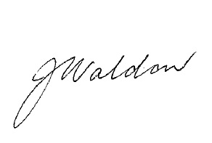Renee Janssen (PE Teacher) Joanne Waldon (Principal)